1. **OPENIE:** Open information extraction (open IE) refers to the extraction of relation tuples, typically binary relations, from plain text, such as (Mark Zuckerberg; founded; Facebook).

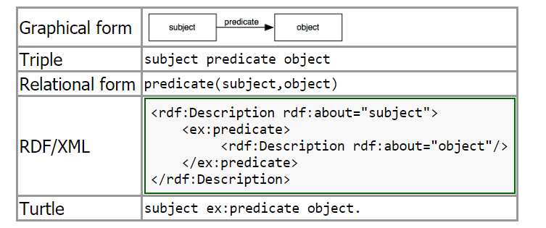

1. **Conversion of relations to rdf:**

For data in batches, conversion would consist of the following

1. Extract the entities: [What is the best entity extraction API + service?](https://www.quora.com/What-is-the-best-entity-extraction-API-+-service)
2. Extract the relationships (much less mature): See [What is the 'state of the art' in nlp relationship extraction?](https://www.quora.com/What-is-the-state-of-the-art-in-nlp-relationship-extraction) and [Relationship Extraction: IBM Watson Developer Cloud](http://www.ibm.com/smarterplanet/us/en/ibmwatson/developercloud/relationship-extraction.html)
3. Transforming the tagged data into RDF via a framework such as Silk, GraphDB or similar: [The Linked Data Integration Framework](http://silk-framework.com/)  [GraphDB FAQ - GraphDB6 - Ontotext Wiki](http://owlim.ontotext.com/display/GraphDB6/GraphDB+FAQ" \t "_blank)
4. In python rdflib

Links:

<https://www.quora.com/How-do-I-convert-unstructured-data-into-RDF-format>

<http://www.iro.umontreal.ca/~lapalme/ForestInsteadOfTheTrees/HTML/ch07s01.html>

**FRED:** FRED is a tool for automatically producing RDF/OWL ontologies and linked data from natural language sentences.

Lithuania adopts the euro as its official currency

